Take Home Exam 05: Small Scale Fracture

Assigned: 09/28/2022
Due (as pdf by email) 10/02/2022 (Sunday) z
•you will receive a simple letter grade for your report
•You may submit your answers in one of two ways:
- For typed answers: as a .docx file (as is) or converted into a pdf file. (DO NOT SEND GOOGLE DOC)
For handwritten answers: Please scan as images, and group together into one pdf file. Or you may hand them manually to my office (ECME-212)

HW 05.1
Consider three materials: A, B and C. The force displacement curve for A is shown below on the far left:
C
B
A

(i) Assume that material B has an elastic modulus that is 150% of A. Draw the curve for B superimposing it on the curve for A (the middle graph above).
(ii) Assume that material C has twice the work of fracture (enthalpy of formation) of material A. Draw the curve for C superimposing it on the curve for A (the graph on the right above).

HW 05.2
In class we discussed the possibility of finding a relationship between the fracture strength (stress to failure), $σ_{F}$ and the flaw size, c. This relationship, as we shall derive in the next class, is given by:
$K_{IC}=σ_{F}\sqrt{c}$ (1)
K_{IC} is called the fracture toughness; it has units of MPa m^{1/2}.
The fracture toughness of glass is approximately 1 MPa m^{1/2}
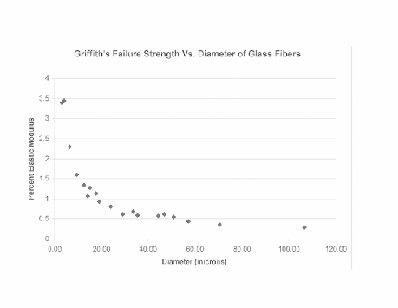
Draw a plot of the fracture stress (in MPa) against the flaw size (in μm), and compare the graph for the data for the fracture strength of glass fibers as a function of the fiber diameter as given below (and also discussed in class):
Compare the plot obtained from Eq. (1) and the experimental plot given above, converting the y-axis in the data into fracture stress expressed (assuming the elastic modulus of glass to be 80 GPa).
Discuss the similarity and the differences between these plots in a couple of lines.

